PollMe

# (Audience Management System)

**BRD**

Introduced by:

# Team 2

**Introduction**

**Executive Summary**

PollMe offers an easy way of interaction between a speaker and his audience. Through taking a poll, ask questions like MCQ and see the percentage of your audience that answered right, get questions from your audience and see this questions on your (mobile / laptop) so no one needs to rise his hand while the speaker is talking and ask the question in front of the audience (which may be annoying or embarrassing to someone to do it). Also, it allows the speaker to get feedback about the topic introduced through a positive or negative poll, which he can see how many people in the audience understand the topic well. PollMe can be used in lectures, conferences, events and any other activities that need a feedback from the audience. The audience doesn’t need to make accounts and password to give their feedback or participate in polls, while the admin only needs to make an account to see the results of the polls and questions he asked or received.

**Document Overview**

This document introduces PollMe (audience management system) product plan. It introduces general description, technical description, development plan, operation plan, cost analysis and marketing study.

**Business Objectives**

* Offer effective way of interacting with your audience.
* Offer easy and effective feedback.
* The project lets a large audience express their opinions.
* The system is easy and understandable.

**Background**

**Introduction [1]**

# We live in the era of the computers and technologies. They are employed in our lives to make it easier and faster. Having a software tool in our different work fields is becoming a must to cope with changes and enhance the product.

We want to improve the educational field, conferences and public communication in halls in general where our tool is applied to make an interactive and responsive audience. The interaction to questions may be pre-determined by the speaker or lecturer. It has been a growing technology in recent years to make a better participation environment and engage higher numbers of people in classes or presentations.

Hardly any of the traditional methods is as effective as such software, to ask students in a class to take a poll or answer questions. This doesn’t allow all of them to participate and provide their opinions. Because it is very time consuming to ask each student all the questions asked in one class or presentation. Plus, an anonymous set of answers make them more credible and less personally oriented.

Therefore, implying our system guarantees effective use of technology to gather answers, draw conclusions, submit questions and provide the lecturer with a feedback for more modifications and enhancements in the future.

**Survey [1]**

There are several organizations which provided a software system for educational polls and interactive learning including the following:

# ARSnova: Learning becomes visible with the mobile audience response service, you can make your lectures and seminars interactive: live and anonymously, the students answer your questions, pose their own questions or give feedback about the pace and understanding of your lecture. The Live Assessment (the learning progress indicator in ARSnova) reflects the students´ level of preparation and the effectiveness of your lecture.

# Poll Everywhere: it is a privately held company headquartered in California. The company, founded in April 2007, is an online service for classroom response audience systems. Poll Everywhere’s product allows audiences and classrooms to use mobile devices to submit their answers.

# Poll Daddy: Is the leading polling software on the Web, it offers the ability to create beautiful polls, view results in eye-catching pie and bar charts, export results, where data analysis can be done.

**Question Types [2]**

**Multiple Choice Questions**

# Multiple choices questions are a form of an objective [assessment](https://en.wikipedia.org/wiki/Educational_assessment) in which respondents are asked to select only correct answers out of the choices from a list. The multiple choice format is most frequently used in [educational](https://en.wikipedia.org/wiki/Education) testing, in [market research](https://en.wikipedia.org/wiki/Market_research), and in [elections](https://en.wikipedia.org/wiki/Elections), when a person chooses between multiple candidates, [parties](https://en.wikipedia.org/wiki/Political_party), or policies.

**General strategies:**

**-** Write questions throughout the term. Multiple-choice question exams are challenging and time-consuming to create. You will find it easier if you write a few questions each week, perhaps after a lecture when the course material is still fresh in your mind

### -Instruct students to select the “best answer” rather than the “correct answer”. By doing this, you acknowledge the fact that the distractors may have an element of truth to them and discourage arguments from students who may argue that their answer is correct as well.

### - Use familiar language. The question should use the same terminology that was used in the course. Avoid using unfamiliar expressions or foreign language terms, unless measuring knowledge of such language is one of the goals of the question. Students are likely to dismiss distractors with unfamiliar terms as incorrect.

### - Avoid giving verbal association clues from the stem in the key. If the key uses words that are very similar to words found in the stem, students are more likely to pick it as the correct answer.

**True/False Questions**

A true or false question consists of a statement that requires a true or false response. There are other variations of the True or False format as well, such as: “yes” or “no”, “correct” or “incorrect”, and “agree” or “disagree” which is often used in surveys. Effective true or false **questions** are factual based, rather than opinion-oriented, and are designed to quickly and efficiently test learner knowledge about a particular idea or concept.

**Concentrate on one key idea or concept:**

### Every true or false question should focus on one specific topic. The primary reason for this is that true or false questions are limited. They do not call for a short answer response, nor are there multiple answers to choose from. The learner is simply being asked to declare whether or not the statement or assertion is based in truth. For example, “all employees must wear their approved uniforms and carry the sales handbook with them at all times” should actually be broken up into two separate true or false questions. It covers two distinct topics and one might be true while the other is false.

**Statements must have a clear, verifiable answer:**

### Each statement must be entirely true or false. There can be absolutely no room for doubt or debate. If the question sits in a gray area and isn’t supported by facts that are found in the eLearning content, then it probably isn’t the best fit for the True or False question format. To create True or False statements that are based in fact, it’s a good idea to go through your learning materials and highlight the key elements of the online lesson. Use these notes as a guide to develop true or false questions that center on the highlighted concepts, rather than trying to cover all aspects of the online lesson in a lengthy True or False exam.

**Link it to the learning objective:**

### Every true or false question should relate to the core learning objectives. Figure out what you are trying to assess before you create each question so that you can align it with the desired outcome. For instance, if you want to determine if a learner grasps the key terminology, develop a series of true or false questions that consists of words and definitions. Ask your learners to determine whether the definitions are, in fact, accurate or inaccurate.

**System Description**

**What is PollMe?**

# To reduce the gap between the speaker and audience , avoid not getting the speaker's point and eliminate the loss of their concentration we are introducing our audience management system . It can be used by presenters, by lecturers, by teachers, in colleges, in forums, in public speeches. The system can measure to what extend your audience understand your presentation through many ways like real-time polls, questions, and live feedback.

## Multi-aiding system

# The surveying system is designed for a wide range of users; teachers in classes, lecturers in universities, and speakers in conferences. Regardless of the domain of use, the system provides easy communication between the audience and the speaker, and a more vivid interaction to improve the understanding of the content. Also, it gives early feedback to the speaker.

## Take a Poll

During the event, the audience can submit their opinions in a poll using their mobiles, and the speakers can gather the information on the spot to solidify their presentation.

## Answer questions

The audience can submit requests to repeat a part during the presentation ask questions and answer MCQs, asked by the speaker, who in return can classify the information and all the questions/answers in a minute.

**System Architecture**

# Audience Management System offers many ways for measuring and processing your audience. This tool can be accessed by mobile and laptop users through web browsers.

# The system can be deployed using local network through Wi-Fi of a router or built-in hotspot, on this network a server (can be a mobile phone or a laptop) and audience’s devices that support Wi-Fi and web-browsing.

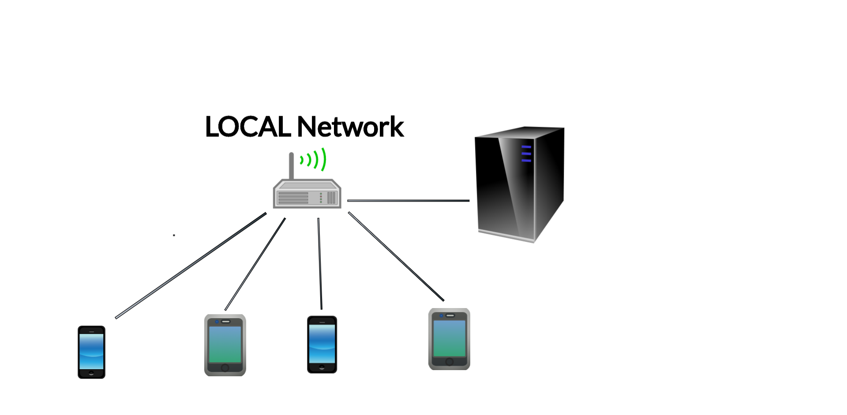

**The system consists of the following parts:**

1. Audience Area
2. Administration Area
3. Data Storage
4. Data Processing
5. Data Analytics

### Audience Area

### This module provides audience with all tools required to do a survey. Audience could be students in college or in a public conference.

Audience can do a survey and submit feedback.

### Administration Area

# This module with all tools required to make a survey. The admin may be a manager in a company, professor or anyone who want to make a specific study.

# Admin can create a survey or a feedback format.

### Data Storage

# System storage uses json format to store the data in a text file on the server locally.

# Audience data storage uses sqlite database and will be also on the server, no external servers are needed.

# The system uses different types of storage:

# System storage for system configurations.

# Admin data storage for storing data by admin.

# Audience data storage for storing all inserted data by audience and admin.

# Analytics storage for storing outcomes of data analytics module.

### Data processing

# By definition, it is the [collection](https://en.wikipedia.org/wiki/Data_collection) and manipulation of items of data to produce meaningful information. The data in our system comes from the submitted answers of the audience. Our system can classify the data under certain criteria. It can determine the number of participants who didn't understand a certain topic, need to a repetition or their opinion of subjects provided by the admin. The admin can review the answers and categorize the answers to gather information allowing him to make data analysis.

### Data Analysis

# C:\Users\Polika\Downloads\771bac5e-3c40-4c27-9574-f09e35ff5129.pngPollMe holds huge amount of contents which includes survey area, feedback area, user interaction and logs. These modules are very important to give the speaker good information which he could use it for example to make a research or to use it like a data to make a specific study or at any facility to know their customer’s feedback. Even in educational area, the professor could use it to make sure that his/her students have totally got the concept of something or to get his/her feedback about the way he teaches this topic.

**System Features**

## Text

# In our audience management system, audience/spectators will be able to deliver questions to the lecturer or the speaker in an easier way instead of traditional way of raising hands.

# We will design a box that can fit up to 100 characters that enables the audience to write the questions they want to ask or ask for more explanation from the lecturer. Audience can also ask for breaks. Therefore, we introduce a way to speak to the lecturer without any noise or raising hands so interaction between the audience and the lecturer will increase and people who are shy or embarrassed to ask the lecturer directly will have nothing to worry about.

## Percentage and absolute results

## Our system is designed to give an instant feedback to the lecturer or speaker from the audience/spectators without needing them to raise their hands and count them. The system shows the lecturer the exact number of audience. When the speaker starts a poll, or asks a multiple choices question or a true or false question every one of the audience get to answer in their audience interface, then the speaker (admin) will see in his admin interface:

# Exactly the absolute number of the audience for each choice/answer.

# The percentage of audience for each choice/answer.

## Cross platform support

## One of our first goals is to make this system compatible with every platform out there, that’s why we decided to turn to web development.

## Our system is developed in a web based environment, that makes it flexible and it will work on any platform either its mobile or desktop interface (with any OS out there).

## Interactive questions

## In our audience management system, our aim is to make the speaker and the audiences interact easily and that will happen when the speaker asks them questions. These questions are MCQ/true or false questions that can help evaluate the audience to see if they understand the topics presented for them.

# There will be two kinds of questions:

1. Questions that are prepared by the lecturer before a lecture or a conference, written in a certain way.

# Questions that come to the speaker’s mind during a lecture or a conference, written instantly so that he can ask the audience. Either way the speaker or the lecturer will be able to control the number of questions that they want to ask. Our aim in the end is to make interaction between audience and the lecturer. We also will be successful in making the lecturer evaluate the audience and their understanding of the topics. Also, the lecturer or the speaker can also know which topic that the audience cannot understand well, so that he can teach it in another way. Therefore, by this, we would have made the gap between the lecturer and the audience closer.

## Feedback

## After sections of the presentation or lecture, the audience can submit their degree of understanding of the part depending on the speaker, if he notices the number of negative feedbacks on the matter is more than 5 for example or any number he decides, he will repeat that part or clarify it.

# Having a feedback is a good way to know if the audiences understand the topic or the lecture very well or not, depending on the question that speaker will submit.

## Password

# We care about the privacy of the information that speaker has on his page, so we locked his data that he only can get accessed to it. Only the admin has a password to enter while the audience can submit their answers without entering usernames and passwords.

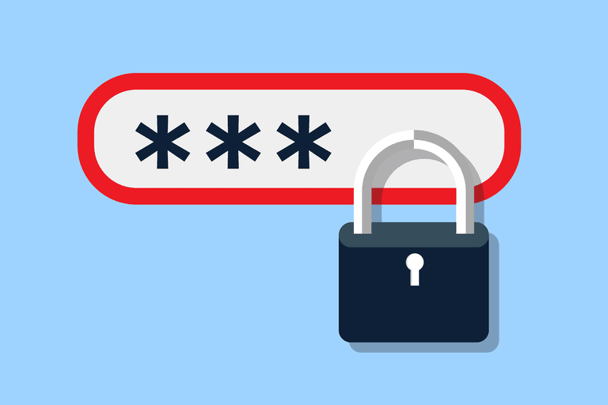

**System Development and Operation**

**Overview**

The system development is performed using agile methodology. The first version of the system should take ten weeks. During those weeks the whole development team will communicate directly with the operation and business team. Later at the last week the system will enter the final operation and maintenance phase. During that phase a minor development team will provide an indirect technical support.

## Development Plan

|  |  |  |  |  |  |  |  |  |  |  |
| --- | --- | --- | --- | --- | --- | --- | --- | --- | --- | --- |
|  | 1 | 2 | 3 | 4 | 5 | 6 | 7 | 8 | 9 | 10 |
| BRD |  |  |  |  |  |  |  |  |  |  |
| Study |  |  |  |  |  |  |  |  |  |  |
| Prototype |  |  |  |  |  |  |  |  |  |  |
| modifications |  |  |  |  |  |  |  |  |  |  |
| Final Release |  |  |  |  |  |  |  |  |  |  |
| deliver |  |  |  |  |  |  |  |  |  |  |

**Team**

|  |  |
| --- | --- |
| **Names** | **Role** |
| 1. Amir Ismaail | * Front – end * Back – end testing |
| 1. Paula Rageb | * Back – end * Front – end testing |
| 1. Beshoy Abdelsayed | * Back – end |
| 1. Joseph Samir | * Back – end * documentation |
| 1. Hamed Abdelrheem | * Front – end * Back – end testing |
| 1. Hassan Mohamed | * Front – end * documentation |
| 1. Hamza Ismaail | * Back – end * Front –end testing |
| 1. Mirna Elhassan | * Back – end |
| 1. Yomna Magdy | * Front – end * documentation |

**Tools**

# We try to develop this system using open source tools, like languages, server and other tools. We may use commercial tools because there is no open source alternative or the alternative doesn’t meet our requirement.

# Here we use online tools for management, tracking, assigning tasks, testing, source control and versioning which will increase the collaboration between team members even if they weren’t located at the same place at the same time.

|  |  |
| --- | --- |
| **Operation** | **Recommended Tools** |
| Source Control and Versioning | GitHub/Git |
| Tasks and Issues Tracking | GitHub/Git |
| Programing Languages | PHP, JavaScript |
| Operating Systems | Windows (its OS independent) |
| Documents | Microsoft word/Excel |
| Web Server | XXAMP (apache server) |
| Communication | Facebook, WhatsApp |

**Cost**

* **We are using free tools.**

**Assumptions**

* The users have mobile phones during the presentation.
* A router or built-in hotspot is available in the conference room.
* No one can vote in a poll more than once
* The system completely depends on free open source tools and languages.

**Limitations**

* Limited area as it uses local network.
* If hosted locally the server may support limited number of active users according to the server’s capabilities.

**References**

1. <https://elearningindustry.com>
2. <https://www.wikipedia.org>